**Vision:**

The Centre of Excellence will soon be able to establish it as a focus for innovation through adequate standardisation, the creation of prototypes, and full support for IoT application solutions.

**Mission:**

The Center of excellence in Internet of Things offers an immersive, interactive environment for students to explore the benefits of the Internet of Things (IoT). With the application of the internet, the number of devices connected to internet is on the rise, most of the industries of today have already started to adopt Internet of Things (IoT) for their operations. IoT provides the industries an effective solution to store the data collected on cloud and carry out various analysis and quick decision making. To gain understanding of complete IoT ecosystem and to practically apply it to projects and tasks requires deep understanding of concepts on IoT, executing it using the entire Hardware & Software Platform.

COE-IOT provides a complete knowledge of Industrial Internet of Things, both in conceptual and practical level. The lab has a complete environment for product creation, testing, validation.

**Objectives:**

By utilising the innovative spirit of our expertise mentors, the COE-IoT primary goal is to develop cutting-edge applications and domain capabilities. The other goals are as follows:

1. To develop cutting-edge software and domain expertise across industries to meet the needs of the nation, including those of smart cities, smart manufacturing, smart agriculture, and others.

2. To create an entrepreneurial ecosystem, start-up community, and talent pool that is industry-ready for IoT.

3. To create an environment that fosters entrepreneurship and allows innovation to flourish.

4. By providing neutral and interoperable, multi-technology stack laboratory facilities, to foster a research attitude and lower R&D costs.

5. To encourage indigenization and lessen reliance on imported IoT components.

**Benefits of Center of Excellence on IoT**

1. Vailability of technology lab for faculty/researchers, students.
2. Industry-standard proficiency courses for upgrading skills. The platform for offering the special course/consulting projects.
3. Access to current research papers related to their work.
4. Innovative ideas from start-up starters, self, etc. Mentor helping students to find research solutions.
5. Students done Internships on IoT projects and access to Industry experts and showcase of talent.

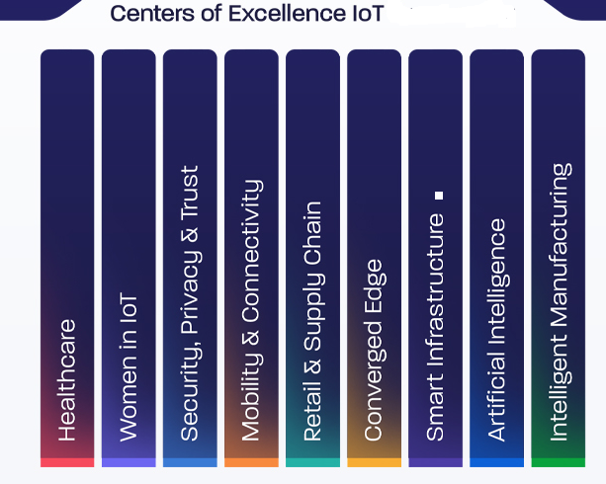

**Focus Area of Research:**

**IoT Cloud**

* Clouds as service provisioning, repository and virtualization platform
* Efficient cloud resource management through AI and learning
* Analytics on acquired data for patterns, prediction and applications.
* Cloud level security, authentication and forensics.

**Middleware**

* Interface of low capability devices with clouds (with context awareness)
* Middleware design distributed processing and QoS/QoE
* Context aware subsystems integration for managing device level diversities.
* Middleware security algorithms

**Devices**

* Application specific device modelling.
* Robotics with embedded AI and machine learning for specific application areas like manufacturing and healthcare.
* Embedded systems for grass root level activities
* Communication interfaces and other related technologies for sensors and actuators
* Design and modelling of scenario/application specific IoT subsystems (E.g. smart home, smart vehicle, mission specific swarm robotics etc.)
* Device and subsystem level light weight security including hardware.

